Here are objective types organized by what makes each one interesting mechanically:
Escort and protection A fragile NPC — a wounded scholar, a captured merchant — must reach the room's exit while you fight. The NPC moves on their own (slowly, stupidly) and enemies prioritize them over you. The tension comes from splitting attention: do you chase down the enemies targeting the NPC, or hold a chokepoint? Variant: the NPC is a bomb carrier who can't be touched by you, only guided by clearing a path.
Puzzle-gated doors The exit is locked and the room contains a spatial puzzle — pressure plates that must be held simultaneously, mirrors that redirect a beam to a crystal, barrels that must be pushed onto floor markers. Enemies still spawn, so the player is solving the puzzle under fire. The key design rule: the puzzle solution should be visible from the start; the difficulty is executing it with enemies attacking.
Survival / holdout No kill condition — the player just has to survive until a timer expires. A portal, a ritual, a beacon. Works best when the room has defensive terrain (barricades, chokepoints) and the enemy spawn rate escalates. The psychological shift from "kill everything" to "just don't die" changes how players move and think entirely.
Ritual disruption Enemies are performing a ritual at one or more altars. Interrupt it by destroying the altars, but each destroyed altar enrages the remaining enemies (speed boost, more spawns, damage increase). Players have to decide the order of disruption — do you kill the altar that's nearly complete first, or take out the one with the weakest guards? This creates a genuine tactical read of the room before engaging.
Resource race A chest full of loot sits in the center. Enemies are racing toward it from the other side. Whoever reaches it first claims it — if enemies get there, they destroy it. The player sprints for the chest knowing they're running toward the enemies rather than waiting. You can layer this with a second chest guarded by a locked door that rewards players who ignore the race.
Trap gauntlet No enemies at all — the room is a field of environmental hazards (spike traps, pendulum blades, fire jets) with a clear path through. Optional: treasure chests hidden off the main path, requiring riskier routes. These rooms are pacing breaks that reward spatial awareness and give players a moment to breathe while still demanding focus.
Stealth passage Enemies have vision cones and patrol routes, and combat is possible but triggers an alarm that locks the exit and floods the room with reinforcements. The objective is to reach the exit — or a specific object in the room — without being seen. Works especially well as a rare room type since it completely inverts normal play. If your rune system penalizes movement speed, suddenly those runes have a new dimension of cost.
Timed extraction A valuable object spawns in the room — a relic, a key, a piece of a map — and the player has a limited window to grab it and exit before the room seals permanently. The object might be on the far side of enemies, or past a puzzle element. Miss the window and the run continues, but a powerful upgrade is permanently lost.
Here's how these objectives map to the kinds of tension they create:
Objective | Combat Pressure | Decision Complexity
Stealth passage | Low | High
Puzzle-gated | Mid | High
Ritual disruption | Mid-high | High
Escort NPC | High | High
Timed extraction | Mid | Mid-high
Resource race | Mid-high | Mid
Trap gauntlet | Low | Low
Survival holdout | High | Low

How to use this for pacing
The tension map reveals a useful design pattern: alternate along the diagonal. A high-pressure, low-decision holdout room followed by a low-pressure, high-decision stealth or puzzle room gives the player genuine recovery time without making the dungeon feel easy. Back-to-back high-pressure rooms cause burnout; back-to-back low-pressure rooms feel like filler.
A rough pacing rhythm that works well for a run of ~10 rooms: open with a standard combat room to set the baseline, sprinkle two or three objective rooms in the middle third, and let the final approach to the portal room be a gauntlet or holdout — something that builds pressure before the payoff of finding the exit.
The stealth room is worth special attention as a "wildcard" — it's the one objective that actively punishes certain rune builds (movement-penalty runes, noisy abilities) while rewarding others. That's a rare opportunity to make the rune system feel like it has real world consequences, which deepens both systems at once.
The core design principle: meaningful asymmetry
Every rune should make you better at something specific while making you worse at something you'd otherwise rely on. Avoid "strictly better" runes — they eliminate decisions. The best trade-offs force players to adapt their playstyle, not just pick the highest number.
Three categories of runes
Think in tiers of impact scope:
Stat runes — simple numerical trade-offs. Easy to understand, easy to balance. Good as common drops.
- +40% attack speed / −25% damage per hit
- +60 max HP / −15% movement speed
- +30% crit chance / crits deal no bonus damage to bosses
Behavior runes — change how an ability works, not just its numbers. More interesting, rarer drops.
- Your attack pierces all enemies in a line, but can no longer hit single targets twice
- Dodging leaves a damaging afterimage, but your actual dodge distance is halved
- Kills heal you for 5 HP, but you can no longer pick up health potions
Identity runes — fundamentally shift the character's game plan. Legendary tier, one per run maximum.
- You deal no damage. Enemies kill each other when they collide. Your job is to herd them.
- You have 1 HP permanently. All damage sources give you a 2-second invincibility window instead.
- Time slows when you stand still. Moving resets a hidden "patience meter."
Rune slots and synergy
Give players a fixed number of rune slots (3–5 works well). This creates a combinatorics puzzle — which runes interact well together? Design some runes to explicitly reference other rune mechanics so players can discover synergies:
- "If you have a movement-penalty rune equipped, gain +80% damage"
- "For each behavior rune equipped, your stat runes gain +20% effectiveness"
This rewards players who read their runes carefully rather than just taking the best individual option.
The offer moment
Trigger
- Occurs every 2–3 rooms on average, after clearing a room
The offer
- Present 3 runes to choose from
- Show full trade-off text for each — upsides in green, downsides in red
- Flag conflicts with already-equipped runes explicitly
Taking a rune
- Behavior changes instantly on equip
- Trade-off becomes immediately active
- Optional: 3-second preview window before committing
Skipping
- Awards a small gold or resource bonus
- Prevents players from feeling forced into a bad rune
- Creates a risk/reward tension for players chasing gold
Continuing
- Run proceeds to the next room either way

When and how you present rune choices matters as much as the runes themselves: The skip bonus is important — it prevents players from feeling forced to take a bad rune. It also creates a subtle risk: players chasing gold might skip good runes and find themselves underpowered later.
Rune rarity and offer weighting
Don't offer three runes at random — weight the pool based on context:
- Earlier rooms: bias toward stat runes (easier to understand when you're still learning the run)
- Later rooms: introduce more behavior and identity runes (player has enough context to evaluate them)
- After a death (if you track run history): weight toward runes that counter how they died — killed by fast enemies? Offer movement or defensive runes
Making trade-offs feel honest
The biggest pitfall is runes where the downside feels invisible until it punishes you unexpectedly. Good practice:
- Show the downside in red text on the offer screen, upside in green — never bury it
- Give players a 3-second preview window where the rune is "active" but can be cancelled, so they feel the trade-off before committing
- If a rune conflicts with an already-equipped rune, flag it explicitly: "Warning: this rune disables your Berserker rune's effect"
Rune removal and commitment
Permanent runes create more tension than removable ones, but consider a middle ground: one "rune swap" token per run, found as a rare drop. Players will hoard it, agonize over when to use it, and feel genuinely rewarded when it bails them out of a bad earlier choice. That agonizing is exactly the engagement you want.
Combat depth breaks down into three interlocking systems — status effects, terrain, and AI behavior. Here's how to design and implement each one, and crucially, how to make them interact with each other.

Status effects
The key design rule: every status effect should change how the player moves, not just deal damage over time. Burn that deals 5 damage per second is boring. Burn that deals 5 damage per second and causes enemies to panic and break formation is interesting.
Core status effect set
Keep the base set small — 5 to 7 effects max. Players need to internalize them all.
- Burn — deals damage over time; burning enemies spread fire to adjacent enemies if they move within 1 tile of each other; extinguished by water terrain
- Freeze — reduces movement speed by 60%; a second application fully roots the enemy; a frozen enemy that takes physical damage shatters, dealing AoE damage to nearby enemies
- Poison — damage over time that accelerates the longer it's applied; stacks up to 3 times; doesn't kill — leaves enemies at 1 HP, making them trivially finishable
- Stun — complete movement and attack lockout for 1.5 seconds; immune to stun again for 4 seconds after recovery (prevents stunlock)
- Slow — 40% speed reduction; stacks with freeze but doesn't stack with itself; interacts with terrain by making enemies unable to traverse difficult terrain like mud or shallow water
- Bleed — damage on movement only; stationary enemies take no bleed damage; causes enemies to stop chasing and hold position if self-preservation AI is enabled
Stacking and interaction rules
Define these explicitly in your codebase before building anything else — they're the hardest thing to retrofit:---
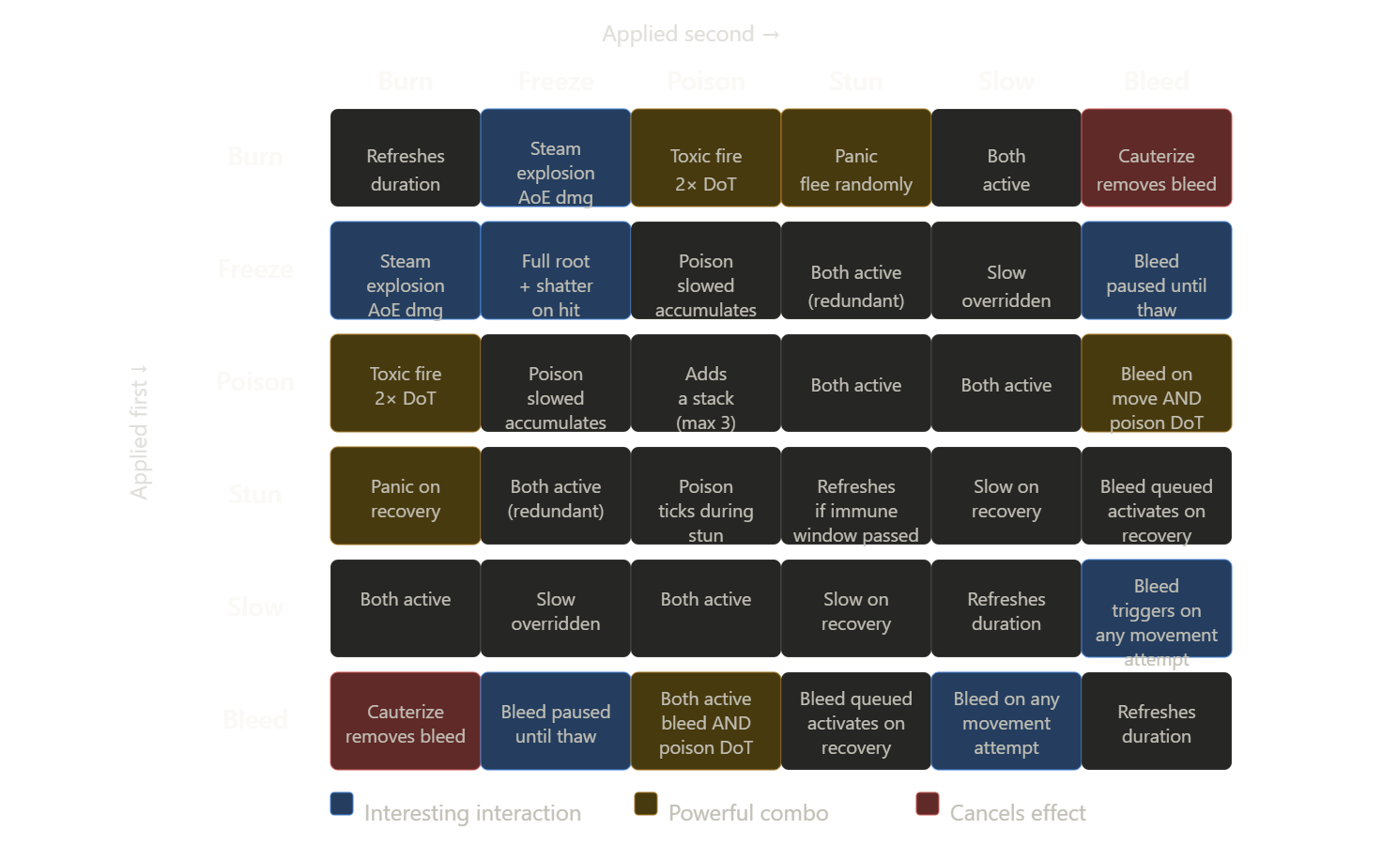
Terrain types and interactions
Terrain does two jobs: it changes how the player and enemies move through space, and it serves as a catalyst for status effect combinations.
Core terrain set
- Water — extinguishes burn; slows all movement by 25%; freeze applied to a water tile spreads ice across the whole puddle, creating a large root zone
- Oil slick — no movement penalty on its own; ignites instantly if any fire source touches it, spreading burn in a 3-tile radius; enemies with fire attacks will accidentally ignite it
- Mud — 50% movement speed reduction; slow-affected enemies become fully rooted in mud; breaks apart after 10 seconds
- Ice — created by freeze hitting water tiles; 30% faster movement (slippery); enemies without ice-adapted AI will slide past their intended position, missing attacks
- Lava — impassable terrain; applies burn on contact with adjacent tiles; can be frozen temporarily into a crossable bridge for 5 seconds
- Pressure plates — trigger a room event (open a gate, drop a cage, release more enemies) when stood on; enemies can trigger them too, which creates interesting accidental consequences
- Elevated ground — ranged attacks fired from high ground gain +25% range; melee enemies pathing to high ground must use ramps, creating natural chokepoints
Terrain generation rules
Don't scatter terrain randomly — give each room a terrain theme with a dominant type and one or two secondary types. A swamp room is mostly mud and water with some oil slicks near enemy spawn points. A volcanic room is mostly normal floor with lava channels and pressure plates over lava pits. This makes each room readable at a glance and lets players plan before engaging.

Enemy AI depth
Status effects and terrain only create depth if enemies respond to them intelligently. Three tiers of AI behavior give you a natural difficulty curve:
Tier 1 — reactive AI (common enemies) Enemies respond to their own status effects. A burning enemy moves erratically and spreads fire by walking near others. A frozen enemy is helpless. A slowed enemy tries to attack from range if they have a ranged attack. This is the baseline — even dumb enemies feel dynamic if their status responses are well-designed.
Tier 2 — tactical AI (elite enemies) Enemies read the terrain and use it deliberately. A fire-immune enemy will deliberately walk through oil slicks to ignite them under the player. A heavy enemy will try to push the player into lava or mud. Enemies with shields will use elevated ground to force the player up a choke ramp. This tier requires pathfinding that's terrain-aware, not just obstacle-aware.
Tier 3 — coordinated AI (rare, boss-adjacent) Enemy groups act as a unit. One enemy applies freeze while another follows up with physical hits to trigger shatters. A support enemy periodically clears status effects from nearby allies. A caller enemy raises an alarm that triggers reinforcements from adjacent rooms if not killed first. This tier is what makes the player feel like they're fighting an organized threat rather than a crowd.

Tying it all together
The real payoff is when all three systems create emergent moments the designer didn't explicitly script. A player kites a burning enemy across an oil slick they didn't place intentionally, accidentally igniting half the room. A frozen enemy slides on ice into a lava channel. A Tier 2 AI pushes the player onto a pressure plate that drops a cage — trapping both of them inside together.
Design for these moments by ensuring every terrain type has at least one status effect it amplifies and one it cancels, and that every enemy AI tier has at least one terrain-aware behavior. The combinations do the rest.

